**St John the Evangelist Anglican Church**

Diocese of Ottawa

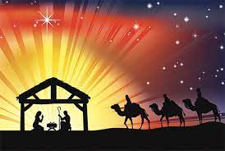

**Christmas Eve**

### December, 24th 2024 at 7pm

### ________________________________________________________________________

You are welcome to participate in smudging as you enter the church to worship. Smudging is a sign of purification and peace offered to anyone who would like to participate. When the weather is too difficult to offer smudging outdoors – and at any time that you are in the church building, dry smudge is available. The sacred medicines – tobacco, sage, sweetgrass, and cedar – are provided at the side chapel. Rub the medicines in your hands and place them in the shell bowl; after use these will be respectfully burned. St John’s is grateful to Indigenous members of our community for offering smudging.

### ________________________________________________________________________

**Prelude** *Noel sur les les flutes   Louis-Claude Daquin*

**Processional Hymn** **118** *O Come, All Ye Faithful* *"Adeste fideles"*

**Welcome**

**The Gathering of the Community**

Dear friends, we gather this day on the traditional and unceded territory of the Algonquin Nation.

**May we always dwell on this land with respect and peace.**

The grace of our Lord Jesus Christ, and the love of God, and the communion of the Holy Spirit, be with you all.

**And also with you.**

**The Collect of the Day**

Let us pray.

*Silence is kept.*

Almighty God, as we prepare with joy to celebrate the gift of the Christ-child, embrace the earth with your glory and be for us a living hope in Jesus Christ our Lord. **Amen.**

## The First Reading *Isaiah 9:2-7*

|  |  |
| --- | --- |
| The people who walked in darkness have seen a great light; those who lived in a land of deep darkness—on them light has shined. You have multiplied the nation, you have increased its joy; they rejoice before you as with joy at the harvest, as people exult when dividing plunder. For the yoke of their burden, and the bar across their shoulders, the rod of their oppressor, you have broken as on the day of Midian.  For all the boots of the tramping warriors and all the garments rolled in blood shall be burned as fuel for the fire. For a child has been born for us, a son given to us; authority rests upon his shoulders; and he is named Wonderful Counsellor, Mighty God, Everlasting Father, Prince of Peace. His authority shall grow continually, and there shall be endless peace for the throne of David and his kingdom. He will establish and uphold it with justice and with righteousness from this time onwards and for evermore. The zeal of the Lord of hosts will do this. | Le peuple qui marchait dans les ténèbres a vu une grande lumière. Sur ceux qui habitaient le pays de l’ombre, une lumière a resplendi. Tu as fait abonder leur allégresse, tu as fait grandir leur joie. Ils se réjouissent devant toi comme on se réjouit à la moisson, comme on jubile au partage du butin. Car le joug qui pesait sur lui, le bâton à son épaule, le gourdin de son chef de corvée, tu les as brisés comme au jour de Madiân.  Tout brodequin dont le piétinement ébranle le sol et tout manteau roulé dans le sang deviennent bons à brûler, proie du feu. Car un enfant nous est né, un fils nous a été donné. La souveraineté est sur ses épaules. On proclame son nom: « Merveilleux - Conseiller, Dieu - Fort, Père à jamais, Prince de la paix. » Il y aura une souveraineté étendue et une paix sans fin pour le trône de David et pour sa royauté, qu’il établira et affermira sur le droit et la justice dès maintenant et pour toujours – l’ardeur du SEIGNEUR de l’univers fera cela. |

Hear what the Spirit is saying to the Church.

**Thanks be to God.**

# Psalm 96

# 

Sing to the Lord a new song;

sing to the Lord, all the whole earth.

Sing to the Lord and bless his Name;

proclaim the good news of his salvation from day to day.

Worship the Lord in the beauty of holiness;

let the whole earth tremble before him.

Tell it out among the nations: "The Lord is King!

he has made the world so firm that it cannot be moved; he will judge the peoples with equity."

Let the heavens rejoice,

and let the earth be glad;

let the sea thunder and all that is in it;

let the field be joyful and all that is therein.

Then shall all the trees of the wood shout for joy before the Lord when he comes,

when he comes to judge the earth.

He will judge the world with righteousness

and the peoples with his truth.

**The Second Reading***Titus 2:11-14*For the grace of God has appeared, bringing salvation to all, training us to renounce impiety and worldly passions, and in the present age to live lives that are self-controlled, upright, and godly, while we wait for the blessed hope and the manifestation of the glory of our great God and Saviour, Jesus Christ. He it is who gave himself for us that he might redeem us from all iniquity and purify for himself a people of his own who are zealous for good deeds  
  
Hear what the Spirit is saying to the Church.  
**Thanks be to God.  
  
Gradual Hymn 126** *Away in a Manger***The Gospel***Luke 2:1-20*

The Lord be with you.

**And also with you.**

The Holy Gospel of our Lord Jesus Christ according to Luke.

**Glory to you, Lord Jesus Christ.**

In those days a decree went out from Emperor Augustus that all the world should be registered. This was the first registration and was taken while Quirinius was governor of Syria. All went to their own towns to be registered. Joseph also went from the town of Nazareth in Galilee to Judea, to the city of David called Bethlehem, because he was descended from the house and family of David. He went to be registered with Mary, to whom he was engaged and who was expecting a child. While they were there, the time came for her to deliver her child. And she gave birth to her firstborn son and wrapped him in bands of cloth, and laid him in a manger, because there was no place for them in the inn.

In that region there were shepherds living in the fields, keeping watch over their flock by night. Then an angel of the Lord stood before them, and the glory of the Lord shone around them, and they were terrified. But the angel said to them, ‘Do not be afraid; for see—I am bringing you good news of great joy for all the people: to you is born this day in the city of David a Saviour, who is the Messiah, the Lord. This will be a sign for you: you will find a child wrapped in bands of cloth and lying in a manger.’ And suddenly there was with the angel a multitude of the heavenly host, praising God and saying, ‘Glory to God in the highest heaven, and on earth peace among those whom he favours!’

When the angels had left them and gone into heaven, the shepherds said to one another, ‘Let us go now to Bethlehem and see this thing that has taken place, which the Lord has made known to us.’ So, they went with haste and found Mary and Joseph, and the child lying in the manger. When they saw this, they made known what had been told them about this child; and all who heard it were amazed at what the shepherds told them. But Mary treasured all these words and pondered them in her heart. The shepherds returned, glorifying and praising God for all they had heard and seen, as it had been told them.

The Gospel of Christ.

**Praise to you, Lord Jesus Christ.**

**Sermon** *The Reverend Canon Gary van der Meer*

**Solo** *Shepherds watch in the fields    Peter Cornelius*

*Luka Eriksen*

**The** **Prayers of the People**

**The Peace**

May the peace of Christ be always with you.

**And also with you.**

**Offertory Hymn 140** *It came upon the midnight clear  "Carol"*

|  |  |
| --- | --- |
| *The offering plates are passed through the congregation during the hymn. Financial gifts support the presence and ministries of St John’s including Sunday worship and our many community initiatives. Your support is welcome but not required to participate in the life of this community. You may choose to place a gift on the plate or give it to a greeter at the conclusion of the service. If you already give financial support to St John’s by other means – such as monthly Pre-Authorized Remittance (PAR) or QR Code – you are invited to place a small card on the plate (called a “PAR Chit”). PAR Chits are found at back of the church beside the nametags.* | **Donations** |

**The Prayer over the Gifts**

Source of light and gladness, accept all we offer on this joyful feast. May we grow up in him who unites our lives to yours; for he is Lord now and for ever. **Amen.**

**The Celebration of the Eucharist**

May God be with you.

**And also with you.**

Lift up your hearts.

**We lift our hearts to God.**

Let us give thanks to God our creator.

**It is right to give our thanks and praise.**

Blessed are you, gracious God, creator of heaven and earth; we give you thanks and praise through Jesus Christ our Lord, who in the fullness of time came among us in our flesh, and opened to us the way of salvation. Now we watch for the day when he will come again in power and great triumph to judge this world, that we, without shame or fear, may rejoice to behold his appearing. Therefore we praise you, joining our voices with angels and archangels and with all the company of heaven, who for ever sing this hymn to proclaim the glory of your name.

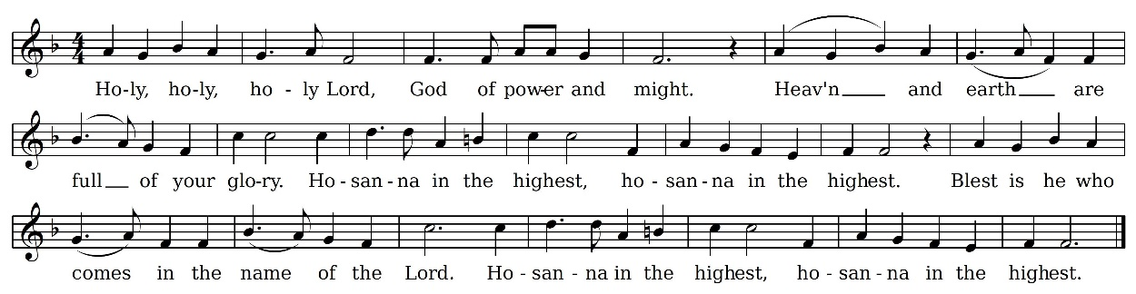

We give thanks to you, Lord our God, for the goodness and love you have made known to us in creation; in calling Israel to be your people; in your Word spoken through the prophets; and above all in the Word made flesh, Jesus your Son. For in these last days you sent him to be incarnate from the Virgin Mary, to be the Saviour and Redeemer of the world. In him, you have delivered us from evil, and made us worthy to stand before you. In him, you have brought us out of error into truth, out of sin into righteousness, out of death into life.

On the night he was handed over to suffering and death, a death he freely accepted, our Lord Jesus Christ took bread; and when he had given thanks to you, he broke it, and gave it to his disciples, and said, “Take, eat: this is my body which is given for you. Do this for the remembrance of me.”

After supper he took the cup of wine; and when he had given thanks, he gave it to them, and said, “Drink this, all of you: this is my blood of the new covenant, which is shed for you and for many for the forgiveness of sins. Whenever you drink it, do this for the remembrance of me.”

Therefore, Father, according to his command,

**we remember his death,**

**we proclaim his resurrection,**

**we await his coming in glory**;

and we offer our sacrifice of praise and thanksgiving to you, Lord of all; presenting to you, from your creation, this bread and this wine. We pray you, gracious God, to send your Holy Spirit upon these gifts, that they may be the sacrament of the body of Christ and his blood of the new covenant.

Unite us to your Son in his sacrifice, that we, made acceptable in him, may be sanctified by the Holy Spirit. In the fullness of time, reconcile all things in Christ, and make them new, and bring us to that city of light where you dwell with all your sons and daughters; through Jesus Christ our Lord, the firstborn of all creation, the head of the Church, and the author of our salvation; by whom, and with whom, and in whom, in the unity of the Holy Spirit, all honour and glory are yours, almighty Father, now and for ever. **Amen.**

**The Lord’s Prayer**

As our Saviour taught us, let us pray:

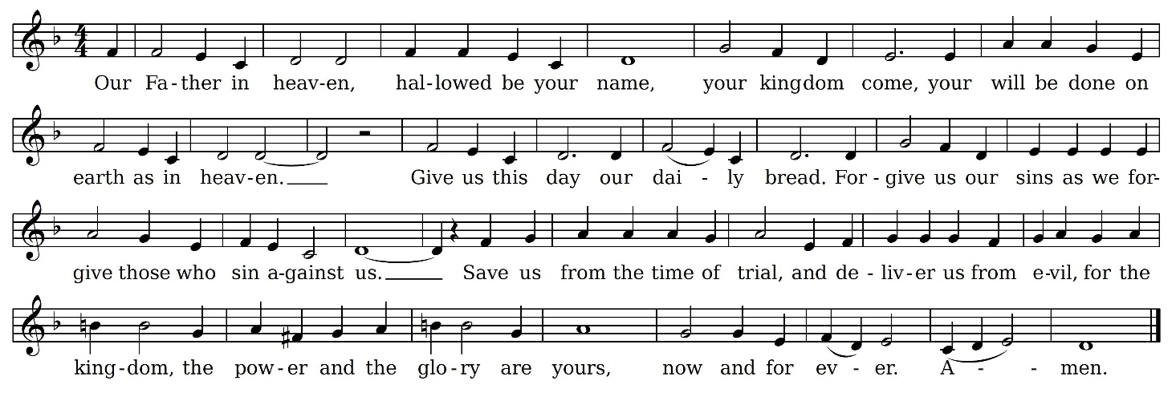

**The Breaking of the Bread**

*Silence is kept.*

We break the bread of life,  
and that life is the light of the world.  
**God here among us, light in the midst of us, bring us to light and life.**

The gifts of God for the People of God.

**Thanks be to God.**

**Communion** *Improvisation on "Stille Nacht"  Clifford Robertson*

*All are welcome to come forward to participate in the Eucharist. Please request a gluten-free wafer if required or a blessing if desired.*

**Prayer after Communion**

Let us pray.

*Silence is kept.*

God of all, tonight you have united earth and heaven in sending your Son to be one of us. May we who have tasted heavenly things share them with our hurting world. We ask this in the name of Jesus Christ our Lord. **Amen.**

**Candle Lighting Carol 119** *Silent Night*

*The church will darken as our candles are lit. Please extinguish your candle at the conclusion of the carol.*

Silent Night! Holy Night! All is calm, all is bright round yon virgin mother and child, Holy infant so tender and mild, sleep in heavenly peace, sleep in heavenly peace.

Silent Night! Holy Night! Shepherds quake at the sight; glories stream from heaven afar, heavenly hosts sing alleluia, Christ the Saviour is born, Christ the Saviour is born.

Silent Night! Holy night! Son of God, love’s pure light radiant beams from thy holy face, with the dawn of redeeming grace, Jesus, Lord, at thy birth. Jesus, Lord, at thy birth.

**Announcements**

**Doxology**

Glory to God,

**whose power, working in us, can do infinitely more than we can ask or imagine. Glory to God from generation to generation, in the church and in Christ Jesus, for ever and ever. Amen.**

**Blessing**

**Recessional** **Hymn 138** *Hark! The Herald Angels Sing*

**Dismissal**

Go in peace to love and serve the Lord.

**Thanks be to God.**

**Postlude** *Noel Suisse    Louis-Claude Daquin*

________________________________________________________________________

*Preacher/ Presider* The Reverend Canon Gary van der Meer

*Interim Director of Music* Tom Annand

*Lead Warden* Marianne Harkema

*Crucifer* Sherrie Dagg

*Server* Idris Bachene and Anastasie Barabiraho

*Intercessor* Brian Cameron

*Readers* Christina Guest and Marianne Harkema

*Cantor* Luka Eriksen

*Communion Assistants* Sherrie Dagg and Jane Maxwell

*Sidespeople* Margot Cameron and Jill Moll

*Tower Bell* Jill Moll

*Altar Guild* Brian and Margot Cameron

*Audio Tech & Lock up Duty* Peggy Lister

________________________________________________________________________

Liturgy: *The Book of Alternative Services* c 1985 by the General Synod of the Anglican Church of Canada, used with permission. *Revised Common Lectionary Prayers* (2002) alt. *Copyright © 2001 by the General Synod of the Anglican Church of Canada. . Collectif. La Traduction oecuménique de la Bible (TOB), à notes essentielles: 1360 (French Edition) (p. 4431). BIBLI'O. Kindle Edition.*  *Music © 2001 Gordon Johnston*

**